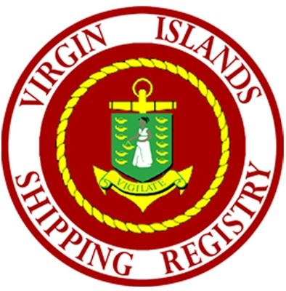
VIRGIN ISLANDS SHIPPING REGISTRY
PREMIER’S OFFICE
1ST FLOOR, RITTER HOUSE, P.O. Box 4751, ROAD TOWN, TORTOLA
Tel: +1 (284) 468-9646 Email: vishipping@bvimaritime.vg
----------------------------------------------------------------------------------------------------------------------------------
CRUISING AND HOME PORT PERMIT ACT, 2021
No. 29 of 2021

Application for a
HOME PORT PERMIT | SPECIAL PERMIT

SHIP DETAILS
Name of Ship | Official Number | Callsign
Length overall (m) | Port of Registry | Gross tonnage
Name and Address of Owner | Name and Address of Operator | Name and Address of Agent
SHIP STATUS DETAILS
Date of last PSC: | Date of last trip to the VI: | Level of current MARSEC:
[date], | [date],
Fuel Grade: | Sewage Quantity/Capacity: | Sludge Quantity/Capacity:
 | / | /
Enough Food on board: | Undeclared Dangerous Goods: | All Crew Certified:
Crew being held on board against their will? | Crew’s wages overdue for payment? | Travel/Hotel arrangement for signing off crew completed?
Type of Permit Application: HOME PORT PERMIT SPECIAL PERMIT
(Please see required documents below)
CONTACT INFORMATION:

Name: Contact Number:

Date: [date], Email:

Signature: __________________________________________
FOR OFFICIAL USE ONLY
REQUIRED DOCUMENTS
Reviewed by:
Date Reviewed:
Prepared by:
Date Prepared:
Application Approval:

Fees
Certificate of Registry
Certificate Documentation
Port Sate Control Inspection

[date],

[date],
Approved Rejected
Comments:

