(SESOC No.)
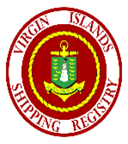
STATEMENT OF COMPLIANCE CARGO SHIP SAFETY EQUIPMENT
as applicable to a vessel of less than 500 Gross Tons* under the provisions of
THE INTERNATIONAL CONVENTION FOR THE SAFETY OF LIFE AT SEA, 1974,
as modified by the Protocol of 1988 relating thereto, as applicable to vessels of less than 500 gross tons*
This Statement shall be supplemented by a Record of Equipment
Issued under the authority of the
Government of the VIRGIN ISLANDS
by

THE VIRGIN ISLANDS SHIPPING REGISTRY

PARTICULARS OF SHIP:
name of ship
distinctive number or letters
port of registry
gross tonnage
IMO NUMBER
TYPE OF SHIP
DATE ON WHICH KEEL WAS LAID

This is to state that:
- The above vessel is below Convention size regarding the provisions of the International Convention for the Safety of Life at Sea, 1974, as modified by the protocol 1988 relating threreto.
- The ship has been surveyed in accordance with the cargo ship safety equipment requirements of Chapters II-2, III, IV and V of the Convention, as applicable to vessels of less than 500 gross tons *,
- The survey showed that:
  - the ship complied with the requirements of the Convention, as applicable, * as regards fire safety systems and appliances and fire control plans;
  - the life saving appliances were provided in accordance with the requirements of the Convention, as applicable, *;
  - the ship was provided with a line-throwing appliance, and radio installations used in lifesaving applicanes in accordance with the requirements of the Convention,
  - the ship was provided with lights, shapes and means of making sound signals and distress signals in accordance with the requirements of the Convention and the International Regulations for Preventing Collisions at Sea in force;
  - in all other respects the ship complied with the relevant requirements of the Convention, as applicable, *.
4. An Exemption Certificate been issued.

* IACS Recommendations for the Safety of Cargo Vessels of Less Than Convention Size (Rev. 2 April 1999) additionally applicable to a vessel registered under an IACS member.

This statement is valid until: subject to the annual and periodical surveys.

Completion date of the survey on which this statement is based:

Issued at: Road Town, Tortola
(Place of issue of certificate)

26

Official

Stamp
(Date of issue)

................................................................
(Signature of authorized official issuing the certificate)

(Name of authorized official issuing the certificate)

This certificate is issued by or on behalf of the British Virgin Islands under the responsibility of the United Kingdom as flag-state under the Convention.
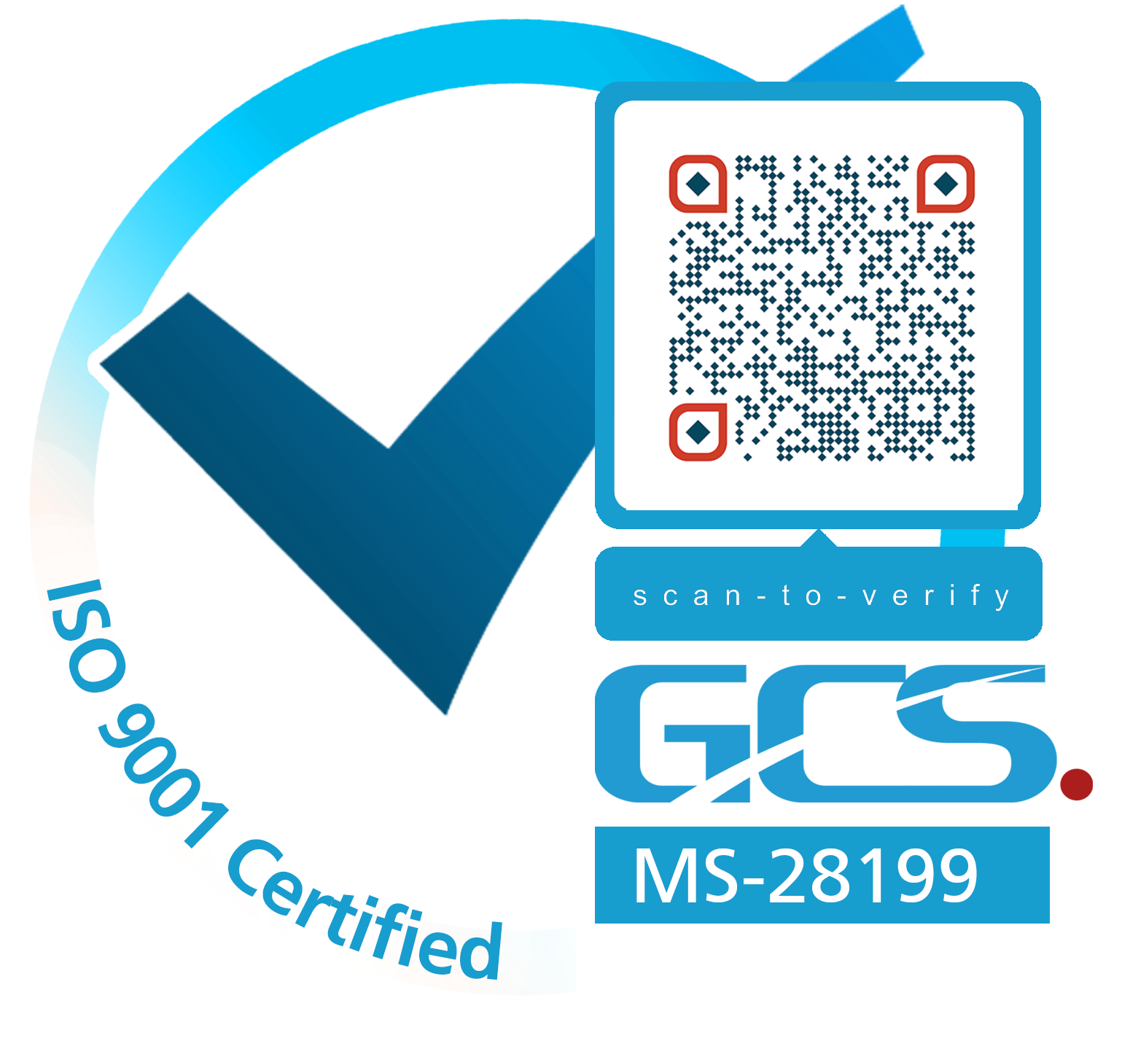

(SEC No. 错误!未找到引用源。/错误!未找到引用源。) SAFETY EQUIPMENT STATEMENT OF COMPLIANCE

Name of ship: 错误!未找到引用源。 Distinctive numbers or letters:错误!未找到引用源。
----------------------------------------------------------------------------------------------------------------------------------------------

ENDORSEMENT FOR ANNUAL AND PERIODICAL SURVEYS

THIS IS TO CERTIFY THAT at a survey, the ship was found to comply with the relevant requirements of the Convention as applicable to vessels of less than 500 gross tons, *.
----------------------------------------------------------------------------------------------------------------------------------------------

Annual survey Signed: ........................................................
(signature of authorised official)

Official
Stamp

Place:

Date:

Annual / Periodical** survey Signed: ........................................................
(signature of authorised official)

Official
Stamp

Place:

Date:

Annual / Periodical** survey Signed: ............................................................
(signature of authorised official)

Official
Stamp

Place:

Date:

Annual survey Signed: ..........................................................
(signature of authorised official)

Official
Stamp

Place:

Date:

-------------------------------------------------------------------------------------------------------------------------------------------------------------

Endorsement to extend the validity of the certificate until reaching the port of survey or for a period of up to three months.

This certificate shall be accepted as valid until:

Signed: ................................................................

Official
Stamp
(signature of authorised official)

Place:

Date:

* IACS Recommendations for the Safety of Cargo Vessels of Less Than Convention Size (Rev. 2 April 1999) additionally applicable to a vessel registered under an IACS member.

** delete as appropriate

